Science Reviewer
DNA Composition and Structure
Definition of Terms:
- Genetic Terms:
- Heredity – The passing of traits or characteristics from parents to their offspring.
- Inheritance – The process through which traits are transmitted from one generation to the next through genes.
- Variations – The differences in traits among individuals of the same species, caused by genetic factors or the environment.
- Allele – A different form of a gene that determines specific traits, such as eye color or blood type.
- Codon – A group of three nitrogen bases in DNA or RNA that codes for a specific amino acid or a signal to start or stop protein synthesis.
- DNA (Deoxyribonucleic Acid) – The molecule that carries the genetic information of an organism; it contains instructions for building and maintaining life.
- RNA (Ribonucleic Acid) – A molecule that helps carry out the instructions in DNA by guiding protein synthesis.
- Chromosomes – Thread-like structures found in the nucleus of cells that carry genetic information, made of DNA and proteins.
- Gene – A specific segment of DNA that controls a particular trait or gives instructions for making a protein.
- Nucleotides – The basic building blocks of DNA and RNA; each made of a sugar, a phosphate group, and a nitrogen base.

Deoxyribonucleic Acid (DNA):
- DNA (Deoxyribonucleic Acid) - The molecule that carries the genetic information of an organism; it contains instructions for building and maintaining life.
- Structure – Double helix shape – it looks like a twisted ladder. The sides of the ladder are made of alternating sugar (deoxyribose) and phosphate groups.
- The two strands run in opposite directions (antiparallel), allowing the molecule to be stable and capable of replication.
- Composition of DNA – Made up of nucleotides or basic building blocks of DNA and RNA, with 3 primary parts.
- Phosphate Group – Links the sugars together to form the backbone.
- Deoxyribose Sugar – A five-carbon sugar that connects to both the phosphate and the base.
- Nitrogen Base: Using the Base Pairing rule or Chargaff’s Rule. Adenine (A) always pairs with Thymine (T). Cytosine (C) always pairs with Guanine (G)
- Adenine (A)
- Thymine (T)
- Cytosine (C)
- Guanine (G)
- Summary – DNA is a double-stranded molecule made of nucleotides. Its structure – a double helix with complementary base pairing – allows it to store and transmit genetic information accurately.
- Composition of DNA Molecule - Chemical analysis of the chromosomes showed that they are composed protein and DNA (deoxyribonucleic acid) molecules. DNA is a double-stranded nucleic acid composed of building blocks called nucleotides.
- Each nucleotide is composed of three parts with the nitrogenous bases are divided into two groups: purine base and pyrimidine base.
- Five-carbon sugar (deoxyribose),
- Phosphate (PO₄³⁻) and a nitrogenous base.
- Nitrogenous bases are divided into two groups: purine base and pyrimidine base.
- Purine Bases – Are structurally characterized by the presence of a five- sided ring fused to a six- sided ring of carbon and nitrogen atoms (double-ringed structures). Adenine and guanine are the purine bases.
- Pyrimidine Bases – Are structurally characterized by the presence of six-sided ring made up of carbon and nitrogen atoms (single-ringed structures). Cytosine, thymine and uracil are the pyrimidine bases.
- The number of adenine (A) always equals thymine (T), and the number of cytosine (C) always equals guanine (G). This pattern was discovered by Erwin Chargaff.
- DNA has two strands of nucleotides twisted into a helix, with the bases stacked on top of each other.
- Rosalind Franklin and Maurice Wilkins – First few that saw the 3D structure of DNA using x-ray diffraction.
- James Watson and Francis Crick – They worked on the model of the structure of the DNA molecule, using x-ray crystallography. In 1953 they published their work entitled: “The Molecular Structure of Nucleic Acids: A Structure for Deoxyribose Nucleic Acid.”, which won them the Nobel prize.
- Structure of the DNA Molecule - DNA has two strands twisted together, forming a double helix. One full twist of the helix has 10 paired nucleotides. Each strand has a deoxyribose sugar bonded to a phosphate. The nitrogenous bases sit between the two strands, paired like the rungs of a ladder.
- DNA bases are complementary: Adenine (A) pairs with Thymine (T), and Guanine (G) pairs with Cytosine (C).
- These Watson-Crick base pairs are held by hydrogen bonds, which can be double or triple.
- The hydrogen bonds make the DNA twist into a double helix, allowing it to store and pass hereditary information accurately.

Chromosomes:
- Chromosomes – Chromosomes carry genes and determine hereditary traits. They are tightly packed in the nucleus of eukaryotic cells. Each chromosome has histone proteins (ball-shaped) with DNA coiled around them. The word “chromosome” was first used by Walter Flemming.
- Structure:
- Chromasoma – The Greek term where the name chromosome came from, Chroma means color, and Soma which means body. This is because chromosomes can be stained or colored by dyes.
- Nucleoid – In prokaryotes, the chromosome is merely a circle of DNA molecules found in an area in the cytoplasm
- Chromatins – The single linear strands of chromosomes are tightly packed and condensed in the nucleus into discrete structures.
- Sister Chromatids – The double-stranded chromosomes, appear as a highly coiled x-shape structure joined or attached at a certain point by a centromere on each sister chromatid determines its characteristic shape and is used in describing the location of specific genes in the chromosome strand.
- Centromere – The centromere is the pinched area in the pair of chromatids that divides the chromatids into sections called arms.
- P arm – The shorter arm.
- Q arm – The longer arm.
- Types of Chromosomes:
- Metacentric Chromosome – The centromere is in the middle of the chromosome, making both arms almost equal, and it appears V-shaped during cell division.
- Submetacentric Chromosome – The centromere is slightly off-center, making one arm shorter, and it appears L-shaped or J-shaped during cell division.
- Acrocentric Chromosome – The centromere is near one end of the chromosome, with one arm very short (often with a satellite) and the other long, appearing rod-like during cell division.
- Telocentric Chromosome – The centromere is at the tip of the chromosome, showing effectively one arm, and appears I-shaped or a straight rod during cell division.
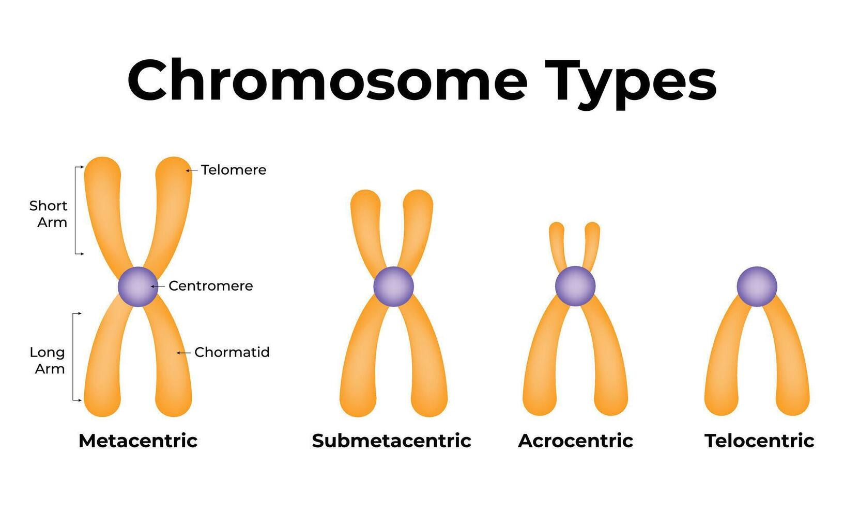
- Homologous Chromosomes – Are pairs that have the same size, shape, and structure, carrying the same genes in the same order, but may have different versions (alleles) of those genes.
- Maternal Chromosome – In sexually reproducing organisms, this one comes from the mother.
- Father Chromosome – In sexually reproducing organisms, this one comes from the father.
- These pairs are called homologous chromosomes because they have the same gene locations (loci) controlling the same traits, but their alleles may differ—for example, one may have the allele for brown eyes and the other for blue eyes
- The diploid number (2N) is the total chromosomes in body cells; humans have 46 chromosomes as 23 homologous pairs.
- Gametes (egg and sperm) have the haploid number (N) of chromosomes. During fertilization, gametes combine, giving a total of 46 chromosomes, a mix from both parents.
- Human Chromosomes – Human chromosomes are thread-like structures in the nucleus that carry DNA, which controls heredity and cellular activities.
- Karyotype – Is an actual picture of the chromosomes from one cell that has been stained and magnified 1000x.
- Cytogenetics – The study of chromosomes
- Humans have 46 chromosomes in 23 pairs:
- 22 pairs of autosomes: Control most body traits and functions
- 1 pair of sex chromosomes: Determine biological sex: XX for female, XY for male
- Each chromosome has:
- Chromatid – One of the two identical halves of a duplicated chromosome.
- Centromere – The constricted region that holds the chromatids together and helps in movement during cell division.
- Short arm (p arm) and Long Arm (q arm) – Parts of the chromosome divided by the centromere.
- Telomeres – Protective ends that prevent chromosomes from sticking to each other or breaking down.
- The Function of Human Chromosomes is:
- Carry genes, which determine traits like eye color, blood type, and height.
- Ensure accurate DNA replication and equal distribution of genetic material during cell division (mitosis and meiosis).

Ribonucleic Acid (RNA):
- RNA (Ribonucleic Acid) – Is a single-stranded nucleic acid that plays a key role in carrying out the genetic instructions stored in DNA to make proteins – the molecules that perform most functions in cells.
- RNA is found in the nucleus (nucleolus), in the cytoplasm as free ribosomes, and attached to the endoplasmic reticulum.
- It is key in protein synthesis, made in the nucleolus and transferred to ribosomes, the protein factories.
- Structure of RNA – RNA is single-stranded and made of nucleotides, each with:
- Ribose sugar
- Phosphate group
- One of four nitrogen bases: Adenine (A), Uracil (U) (replaces Thymine), Cytosine (C), Guanine (G)
- Types of RNA:
- mRNA Messenger RNA – Carries the genetic code from DNA in the nucleus to the ribosomes in the cytoplasm.
- tRNA Transfer RNA – Brings specific amino acids to the ribosome to build the protein chain according to the mRNA code.
- rRNA Ribosomal RNA – Combines with proteins to form ribosomes, the site where proteins are assembled.
- Transmission of traits is how characteristics pass from parents to offspring through DNA, genes, and chromosomes, which together determine an organism’s traits.

Roles of DNA, RNA, Genes, and Chromosomes in the Transmission of Traits:
- DNA – Deoxyribonucleic acid is the molecule that stores genetic information. It carries instructions for making proteins, which determine the structure, function, and traits of an organism.
- RNA – Ribonucleic acid acts as a messenger and helper in protein synthesis. mRNA carries the coded instructions from DNA to the ribosome, tRNA brings amino acids, and rRNA forms part of the ribosome, ensuring that DNA instructions are translated into proteins.
- Genes – Segments of DNA that code for specific traits or proteins. Each gene determines a characteristic, such as eye color or blood type, and is passed from parents to offspring, influencing heredity.
- Chromosomes – Thread-like structures in the cell nucleus made of DNA and proteins. They organize and package genes, ensuring that genetic information is accurately transmitted during cell division. Humans have 46 chromosomes (23 pairs), which carry all hereditary traits.
- These four components work together: DNA contains genes, genes are organized on chromosomes, and RNA helps express DNA’s instructions to produce proteins, resulting in the transmission of traits from one generation to the next.

DNA Replication:
- DNA Replication – The process by which DNA makes an exact copy of itself so that each daughter cell receives the complete genetic information from the mother cell. Replication occurs during the interphase stage of the cell cycle before cell division.
- Initiation – DNA unwinds at specific regions called origins of replication, forming a replication fork. Helicase separates the two strands, and single-strand binding proteins (SSBs) stabilize them.
- Elongation – New complementary strands are synthesized. DNA polymerase adds nucleotides to the growing strand following base-pairing rules (A–T, G–C). The leading strand is synthesized continuously, while the lagging strand is synthesized in Okazaki fragments.
- Termination – Replication ends when the entire DNA molecule has been copied. DNA ligase joins the Okazaki fragments on the lagging strand, forming a continuous strand.
- Result – Two DNA molecules, each with one original strand and one new strand, ensuring genetic continuity in daughter cells
- Semi-Conservative Replication – A method of DNA replication in which each of the two new DNA molecules contains one original (parental) strand and one newly synthesized strand. This method was confirmed by Matthew Meselson and Franklin Stahl (1958) through their experiment using nitrogen isotopes.

Protein Synthesis:
- Protein Synthesis – The process by which cells build or manufacture proteins. It involves a series of biochemical reactions that transform DNA into RNA and then into proteins. Protein synthesis begins in the nucleus and ends in the ribosomes of all cells.
- Transcription – The first step of protein synthesis in which DNA is used as a template to produce a complementary RNA molecule. During transcription, RNA polymerase reads the DNA sequence and forms messenger RNA (mRNA), which carries the genetic code from the nucleus to the ribosome.
- Translation – The second step of protein synthesis in which the mRNA sequence is decoded to build a specific protein. At the ribosome, transfer RNA (tRNA) brings amino acids corresponding to the codons on the mRNA, and the ribosomal RNA (rRNA) helps link the amino acids, forming a polypeptide chain that folds into a functional protein.

Genetic Code:
- Genetic Code – The sequence of nitrogenous bases in a DNA molecule that carries genetic information. Every three consecutive bases (triplets) form a codon, which is transcribed by mRNA.
- Codons carry the instructions for traits, and two or more codons together determine a specific trait.
- The series of codons forms genes, which control the traits expressed in an organism.
- To express these traits, the language of the codons must be translated into proteins, which perform the functions that result in observable characteristics.
- This is a system developed by geneticists to translate mRNA codons into amino acids.
- The genetic code consists of 64 codons that specify amino acids and three termination (stop) codons, which signal the end of translation, ensuring that proteins are synthesized with the correct sequence and length.

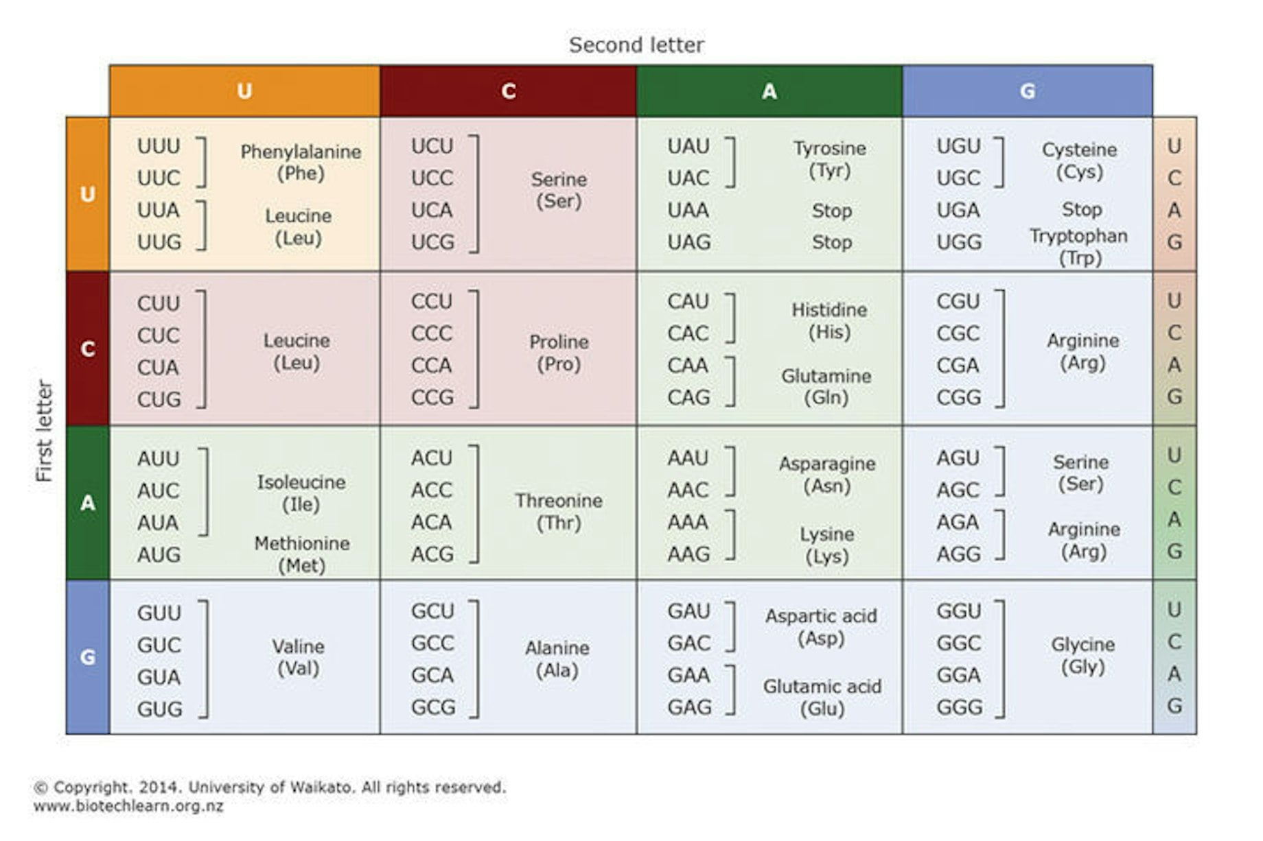

Mutations That Occur in Sex Cells
Mutation:
- Mutation – The appearance of a “new trait” in one generation. This new trait may result from changes in the structure or number of chromosomes (chromosomal mutation) or from any alteration in the sequence of DNA bases (gene mutation).
- Gene Mutation – Genes are segments of DNA located on chromosomes. A gene mutation occurs when the sequence of bases in the DNA molecule is altered.
- Any difference, whether small or large, from the original DNA structure is considered a mutation. These mutations can be small-scale, affecting a few bases, or large-scale, affecting larger sections of DNA.
- Point Mutations – The most common type of gene mutation, resulting from the substitution of a single base (base-pair substitution) that alters the polypeptide sequence.
- Silent Mutations (Synonymous Mutations) – Occur when a nucleotide base is changed to another that codes for the same or a similar amino acid, so the resulting protein remains unchanged.
- Missense Mutations – Occur when a nucleotide base is changed to one that codes for a different amino acid, causing an alteration in the resulting protein.
- Nonsense Mutations – Occur when a nucleotide base is replaced by a STOP codon before all codons are read and translated. This prematurely ends translation, producing a nonfunctional protein.
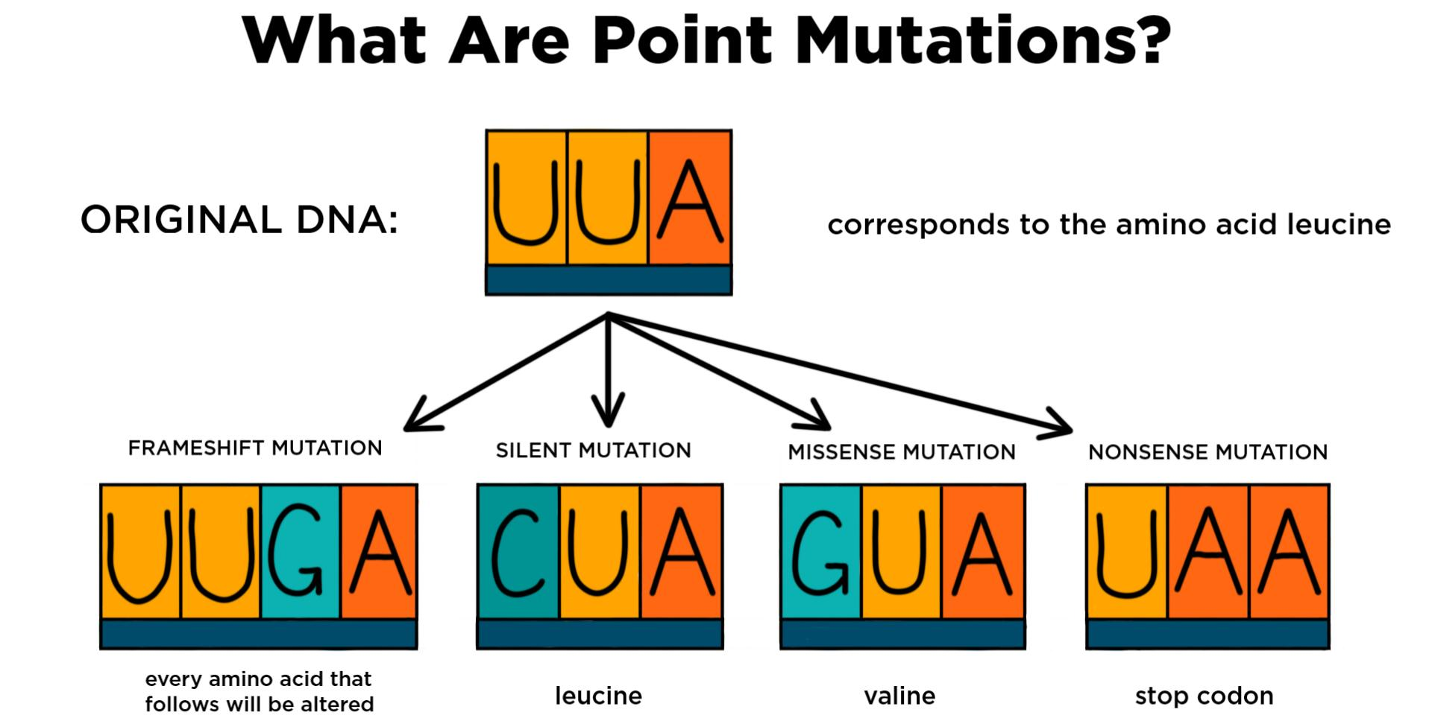
- Base Insertion – A type of gene mutation that involves the addition of an extra base pair into the original DNA sequence. This can cause a shift in the reading frame (frameshift), which often significantly alters the resulting protein.
- Base Deletion – A type of gene mutation in which one or more nucleotide bases are lost from the DNA sequence. This alters the reading frame (frameshift), changing the sequence of codons and consequently affecting the structure and function of the resulting protein.
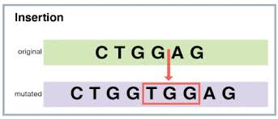 | 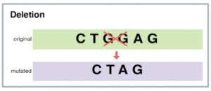
- Large-scale mutations happen when: DNA chunks are lost, repeated, or inserted, gene copies increase, an extra chromosome is added, one allele is lost, a gene section is altered, or a large chromosome portion is deleted.
- Gene Mutation Causes:
- Inheritance – It means one or both parents have the mutation, which is passed to offspring. An inherited mutation is also called a germline mutation.
- Replication – Errors can occur: genes may be substituted, deleted, or added. These errors produce daughter cells that cannot function normally. Such mutations are called acquired mutations. Acquired mutations can be caused by mutagens like harmful chemicals, ultraviolet radiation, and ionizing radiation.
- Effects of Mutations:
- Beneficial Mutations – Occur when mutations produce new protein versions that give positive traits, such as lactose tolerance, malaria resistance, high-altitude adaptation, HIV resistance, reduced cholesterol, increased bone density, and cold adaptation.
- Harmful Mutations - Harmful mutations are random DNA changes that produce proteins that do not function normally or stop functioning. They increase susceptibility to disease, making life harder and sometimes requiring medication. If the mutation causes death, it is lethal. These may include sickle cell anemia, albinism, cystic fibrosis, Down syndrome, muscular dystrophy.
- Mutations that Occur in Sex Chromosomes:
- Numerical Mutations (Aneuploidy) – These involve a change in the number of sex chromosomes caused by errors in meiosis (nondisjunction).
- Turner Syndrome (Monosomy X) – Is a numerical mutation caused by missing one X chromosome, resulting in a female with short stature, underdeveloped ovaries, infertility, and sometimes heart defects.
- Klinefelter Syndrome (XXY) – Is a numerical mutation caused by an extra X chromosome in males, resulting in reduced testosterone, infertility, tall stature, and sometimes learning difficulties.
- Triple X Syndrome (XXX) – Is a numerical mutation caused by an extra X chromosome in females, resulting in a normal appearance but sometimes taller height and mild learning difficulties.
- XYY Syndrome (XYY) – Is a numerical mutation caused by an extra Y chromosome in males, resulting in a tall male who may have mild behavior or learning problems.
- Structural Mutations – These involve changes in the structure of the X or Y chromosome such as deletions, duplications or translocations.
- Deletions – Part of the X or Y chromosome is missing, which can cause Duchenne Muscular Dystrophy or color blindness if important genes are lost.
- Duplications – A chromosome segment is repeated, causing abnormal gene dosage and developmental problems.
- Translocations – A segment from one chromosome attaches to another chromosome, which may lead to infertility or miscarriage if important genes are disrupted.
- Isochromosomes – One arm of the X chromosome is missing and the other duplicated, often seen in some Turner syndrome cases.

Non-Mendelian Patterns of Inheritance
Non-Mendelian Patterns of Inheritance:
- Non-Mendelian Patterns of Inheritance – Are genetic inheritance types that do not follow Mendel’s laws of dominance, segregation, and independent assortment. In these patterns, trait expression is more complex, and traits are not determined by a single gene with only two alleles.
- Codominance – Both alleles are expressed equally and distinctly in the heterozygote with no blending, so both traits appear at the same time.
- Example: Human blood group AB (A and B antigens present); Cattle roan coat (red and white hairs appear together).
- Sex-Linked Inheritance – Traits controlled by genes on sex chromosomes (usually X chromosome). Males are more affected by recessive X-linked traits because they have only one X chromosome.
- Example: Color blindness, hemophilia, Duchenne muscular dystrophy – all X-linked recessive disorders.
- Polygenic Inheritance – A single trait is controlled by two or more genes, producing continuous variations. Environmental factors can also influence trait expression.
- Example: Human height, skin color, eye color, and weight; many genes contribute small additive effects to produce the final phenotype.
- Pleiotropy – A single gene influences multiple traits or body systems.
- Example: Sickle cell anemia – one gene mutation affects red blood cell shape, oxygen transport, and organ function; Marfan syndrome – one gene affects connective tissue, impacting heart, eyes, and skeleton.
- Epistasis – One gene masks or modifies the effect of another gene at a different locus.
- Example: Coat color in Labrador retrievers – one gene determines pigment color (black or brown), another gene controls pigment deposition; if the second gene is recessive (ee), the dog will be yellow regardless of the first gene.

